**Project Plan Must Have Facility Manager From Inception – Adebayo**

By

[Emmanuel Badejo](https://www.independent.ng/author/emmanuel/)

August 28, 2019

[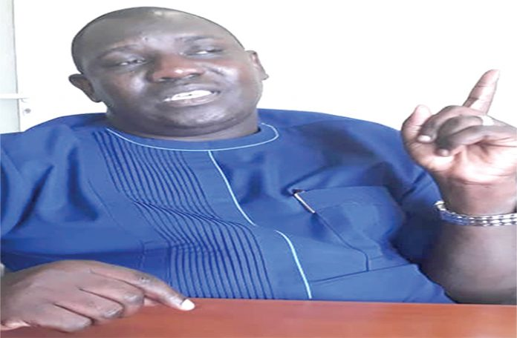](https://www.independent.ng/wp-content/uploads/2019/08/Mr.-Segun-Adebayo.jpg)

Adebayo

***Mr. Segun Adebayo****, former Senior Special Assistant on facility management to the immediate past governor of Ogun State, Senate Ibikunle Amosun, is currently the acting president of International Facility Management Association, Nigeria Chapter. In this interview with* ***EMMANUEL BADEJO****, the trained banker bares his mind on sustainability of all kinds of projects within the real estate and construction industry. EXCERPTS.*

**To some of us, IFMA is known, but it appears the association is unpopular to the public. Do you agree with this view?**

I differ on this with a clear explanation. From our engagements and experience, International Facility Management Association, Nigeria Chapter, popularly known as IFMA has been making a lot of impact. This does not mean that there is continuous need to keep improving day-in, day-out.

One of the programmes we do every year that has been advancing our course, as a group is our annual programme among others. And because we are also a global association, we celebrate world FM Day. It is a global event that brings all facility managers in the world to come together and chart new cause for the industry by looking at our milestones as well as our challenges. This, we have been doing consistently. Each has its theme and we get experts to speak on different areas, particularly, as they affect us and our industry in Nigeria. During our last annual event, which we did in collaboration with Lagos State agency on infrastructure maintenance, we were able to further enhance our relationship with policy makers in Lagos state and in Nigeria in general.

When you look at it from our membership strength, which is 1, 500 now, then, we cannot say IFMA is unpopular. Indeed, IFMA has been around and have been contributing its quota to the development of the nation.

**For the sake of the masses, who is qualified to become IFMA member?**

From qualification perspective, from the nature of the context of the profession, it is multi-disciplinary. So, amongst our members, there are lawyers, architects, bankers, estate surveyors and valuers, builders, etc. But because it is multi-disciplinary, facility management is therefore open to all driven by passion, interest and commitment to a better and conducive environment. When we talk about facility management, what we are talking about is integration of people, process and technology to create an environment that is conducive, work-friendly and also sustainable in terms of management. You are not limited to a section. It is open to all. As human beings, our body is the facility, which we manage from time to time. So, every one that is interested can join IFMA and the means of joining is very seamless. Essentially, IFMA adds value and strives to reinvent the loss value of maintenance culture in Nigeria.

**You spoke about IFMA adding value. To the public and private individuals, what value is IFMA adding, please?**

IFMA adds a lot of value. I will use as an illustration, a recent step undertaken by the Lagos state government through its Ministry of Housing as an example. The ministry showed a commitment to engage members of IFMA not just to create jobs for us, but also to ensure that her estates throughout the state remain habitable and sustainable. For us as experts in facility management, this commitment is a welcome development. Apart from the new rapprochement with Lagos and other state governments, one of the key things we also do is to evaluate state of facilities and in doing that, we offer professional advisory to owners and users of those facilities in terms of providing sustainable management following some set rules from the global point of view.

IFMA has 11 core competencies that speak about all the things we need to have in a building. Two, our primary role is to provide knowledge and deepen capacity of operatives and practitioners. So, every year, we have two strings of professional certified exams for players in the industry. We also have technical and value-adding trainings for members and players in the industry. In that case we deepen the knowledge of all members. We also engage in advocacy on doing what is right at the right time.

You’ll agree with me that Nigeria is still struggling with proper and acceptable maintenance culture and this has given us the leeway as an association to be part of a stakeholders’ meeting where Federal Ministry of Works and Housing invited us to be part of a policy on public building maintenance. Our immediate past president and my humble self represented IFMA and happily, the Federal Executive Council under the first term of President Muhammadu Buhari, did approve that document. Essentially, the document is to encourage right maintenance attitude towards all public assets owned by the federal, states or local governments.

Advertisement

Apart from this, we also do mentorship for technical students, who by the virtue of their trade are useful and critical to the development of the nation. As part of our mentorship programme, we encourage them to undergo their internship with some of our corporate members.

We also do continuous engagement with the stakeholders through our monthly meetings. We also undertake facility tours with a view to adding value around agency and business continuity. When we come to your facility, you conduct us around. We do this to ensure that our facilities are safe, sound and secured. More importantly we collaborate, do advocacy, engagements and many more.

**Most of Nigerian cities are degenerating; buildings in Nigeria are dying. What is IFMA doing to revive these cities and ensure safe and sound buildings?**

One critical point I want to mention is that, to change this narrative, every project plan must have a facility manager integrated in the project schedule from inception. Take for instance, you plan to build an office complex and you assemble your team of professionals from the project manager to civil engineers, to the mechanical engineers and various consultants. You agree that by law, there is no facility manager. But the most important thing is that, how functional will that building be post construction? There is what we call post construction cleaning. So, who cleans after construction? You need to get a professional, who will apply the right tool and resources for the preservation of that building that has just come to life. As a matter of fact, one of the key things we have been advocating for is to have facility managers as part of the project team of any construction irrespective of the type. This was also mentioned during a recent Federal Government’s stakeholders’ meeting. He or she needs to advice you on the types of materials to be used. You need to have a facility manager that will assure that the building won’t degenerate.

There is a case of tenants in Lagos state estates, who are kicking against engaging professional facility managers for their estates. They are saying they have been managing the estates themselves. So, those you have been having as handlers of those estates are not professionals; they not facility managers but estate managers. There is a whole lot of difference between estate managers and facility managers. IFMA has 11 core competencies that guide on how to be the best facility managers of estates. So, our first call to the government is that it is high time you bring facility managers into your project team, be it federal or state estates. This will go a long way in correcting the errors of the past.

Now, with the emergence of a national document on facility management, it is becoming clearer that the government is already thinking along that line. As facility managers, we also help to preserve the life cycle of those assets. So, where you have a directive from the Federal government, it will dovetail into state and local governments. I can tell you that out of the 36 states with the Federal Capital Territory, Lagos state has an agency on facility management; Kaduna has; but Ogun state was the first to appoint an SSA on facility management. We were able to develop a roadmap for the new government to follow. Clearly, we are catching up with the drive. But the smooth, detail and immediate implementation of the national roadmap will accelerate the process, and as such, drive on facility management will dovetail to states and local governments throughout Nigeria. When we have that with our involvement, we would be able to have square peg in square holes and that will effectively reduce the level of degeneration of our buildings across the federation. For me, this a growing concern.

**There are several policies but no implementation. What do you think the nation has been losing without the involvement of facility managers at the mainstream?**

I think our challenge has been what I call multiplicity of documents. But good enough, this document is not duplicated; it is just one document.

Good enough, this has been discussed thoroughly across all sectors. You have everybody speaking same language on the document. What we have been losing is to critically examine potentials of every document because there is no document without its value.

What we need to do is harnessing the potentials of each document into present realities without any ethnic, religious or political coloration.